CREATE THE TABLE

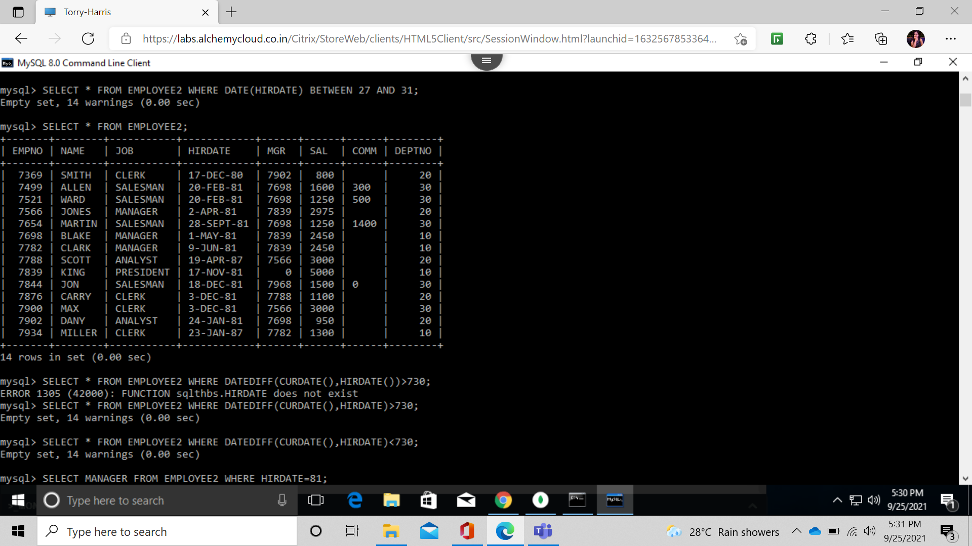

SELECT THE EMPLOYEES IN DEPARTMENT 30.

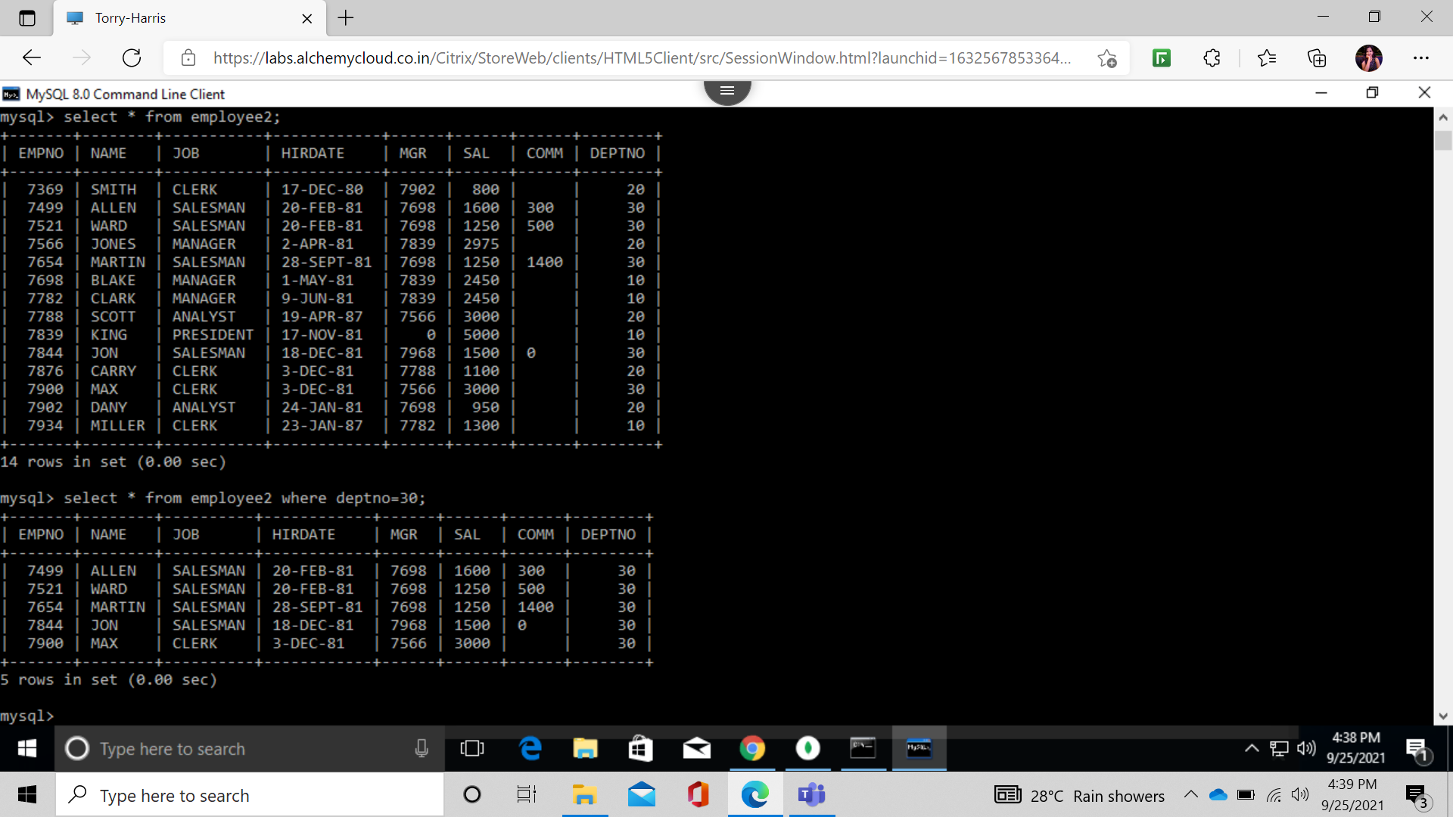

LIST THE NAMES AND DEPT OF ALL CLERKS.

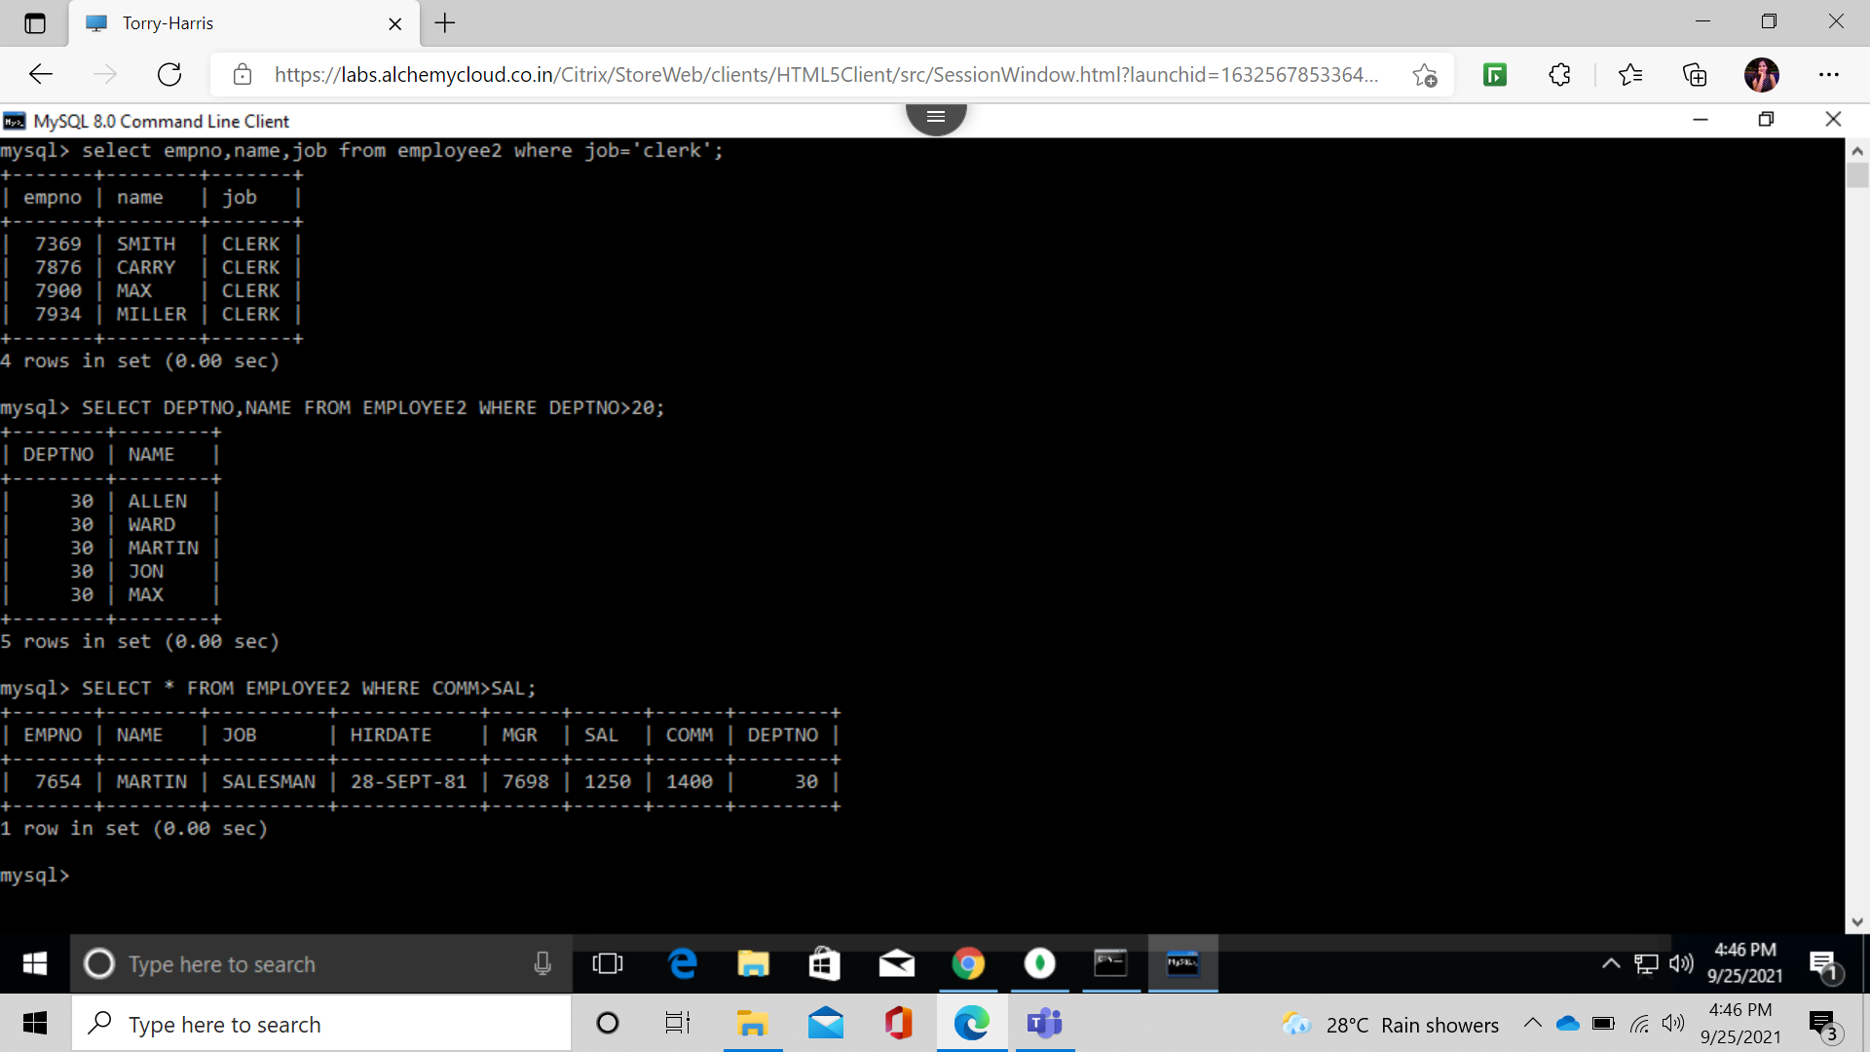

FIND DEPTNO AND NAMES OF EMPLOYEES OF ALL DEPT WITH DEPTNO > 20



FIND ALL EMP WHOSE COMM >SAL;



FIND ALL EMP WHOSE COM IS 60%>SAL;

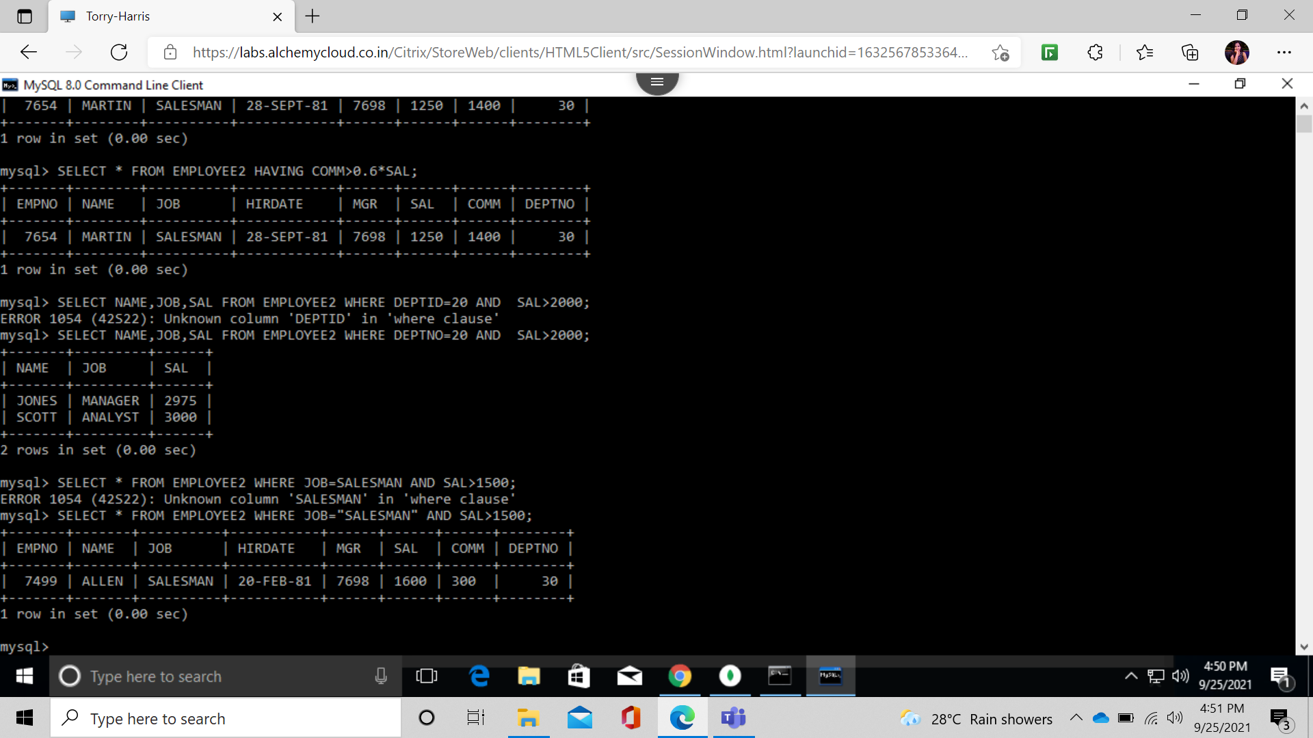

LIST NAME,JOB,SAL OF ALL EMP IN DEPT 20 WHERE SAL>2000;



FIND SALESMAN WHERE SAL>1500;



FIND ALL EMP WHOSE JOB MANAGER OR PRECIDENT;

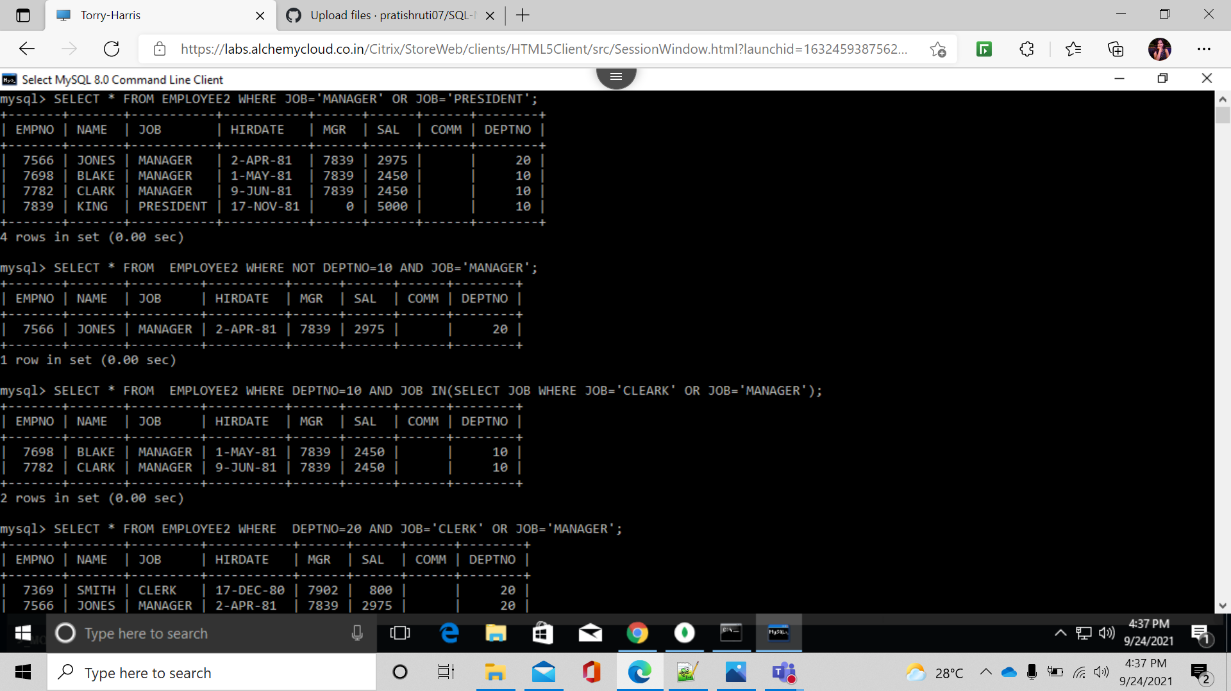

FIND ALL MANAGER WHO ARE NOT DEPT 10;



FIND ALL DETAILS OF MANAGER AND CLERKS IN DEPT 10;



FIND ALL MANAGER AND CLERK IN DEPT 20;



FIND ALL MANAGER IN DEPT 10 ,CLERK IN DEPT 20 AND ALL EMP WHO NEITHER MANAGER OR CLERK BUT SAL>2000;

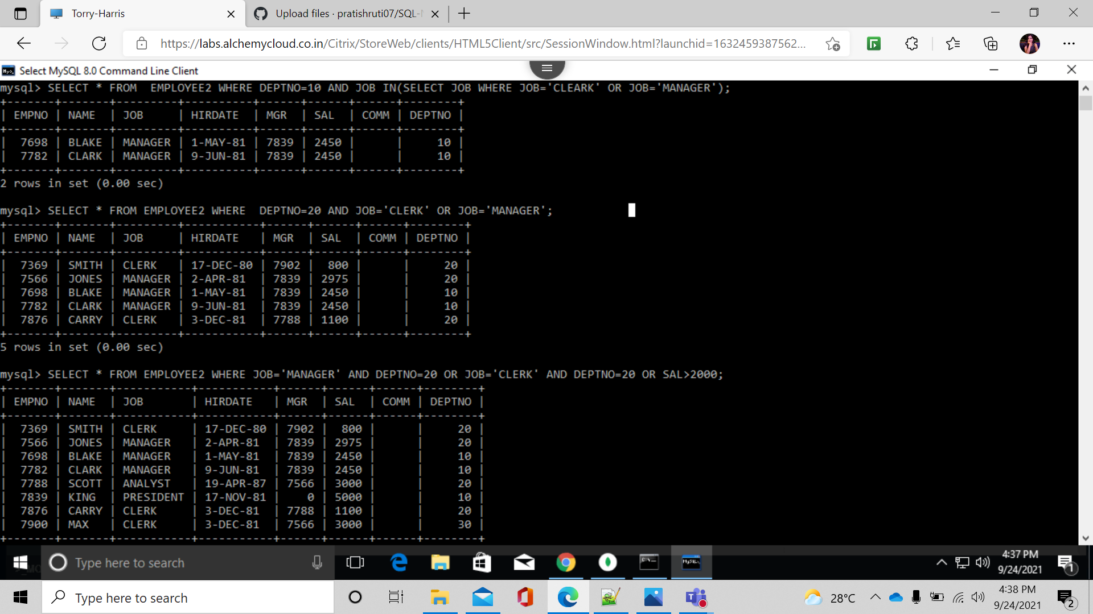

FIND NAMES OF EMP IN DEPT 20 WHO IS NEIGHER MANAGER NOR CLERK;

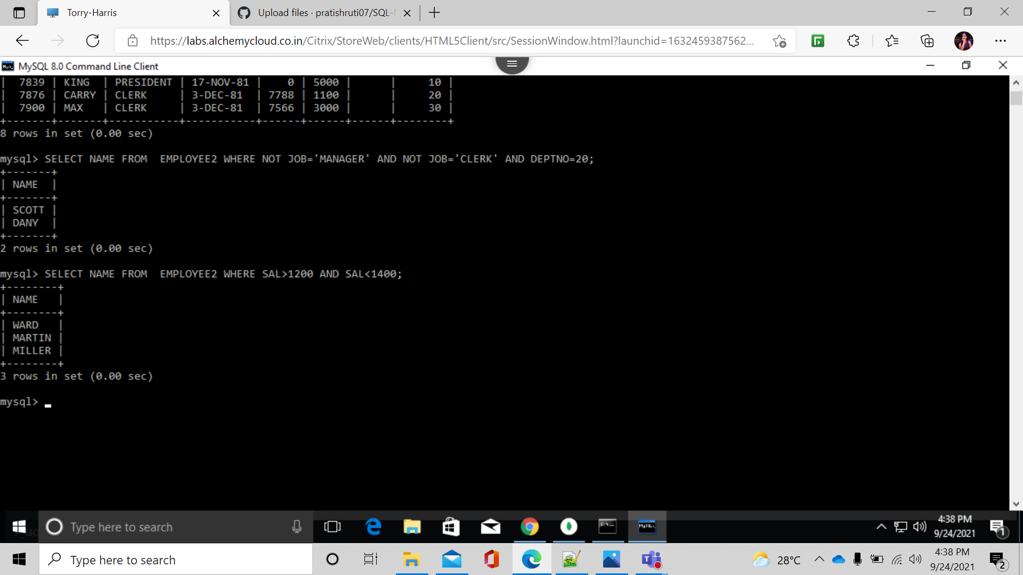

FIND NAMES OF EMP WHOSE SAL IS BETWEEN 1200 AND 1400;



FIND EMP WHO ARE CLEARK,ANALYST OR SALESMAN;

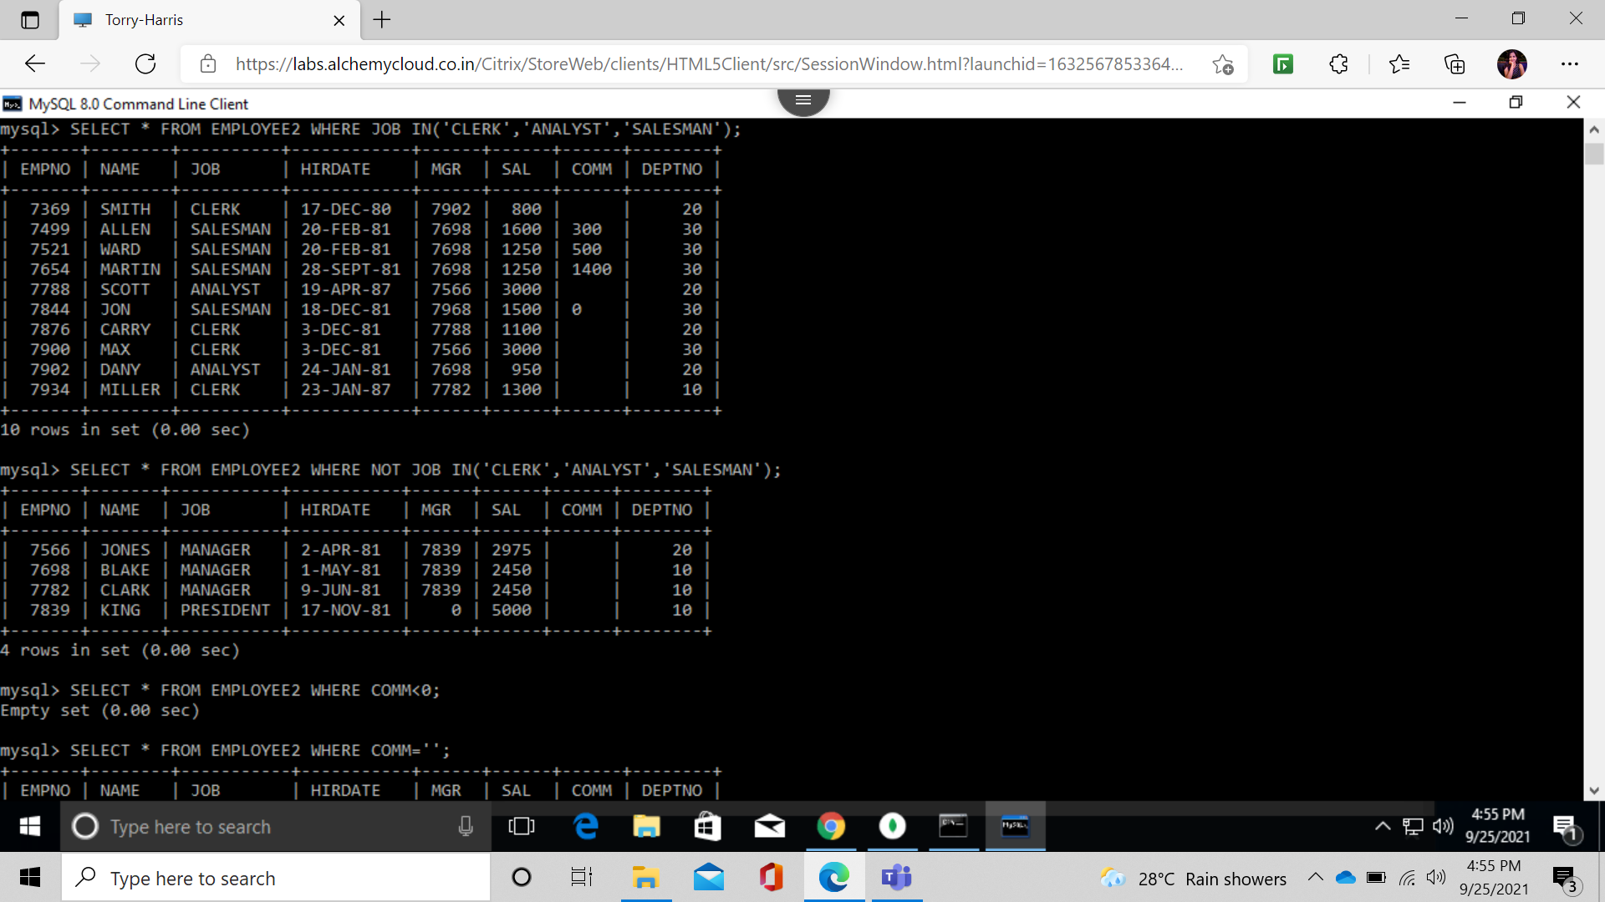

FIND EMP WHO ARE NOT CLEARK,ANALYST OR SALESMAN;



FIND EMP WHO DONT RECIVE COMM;

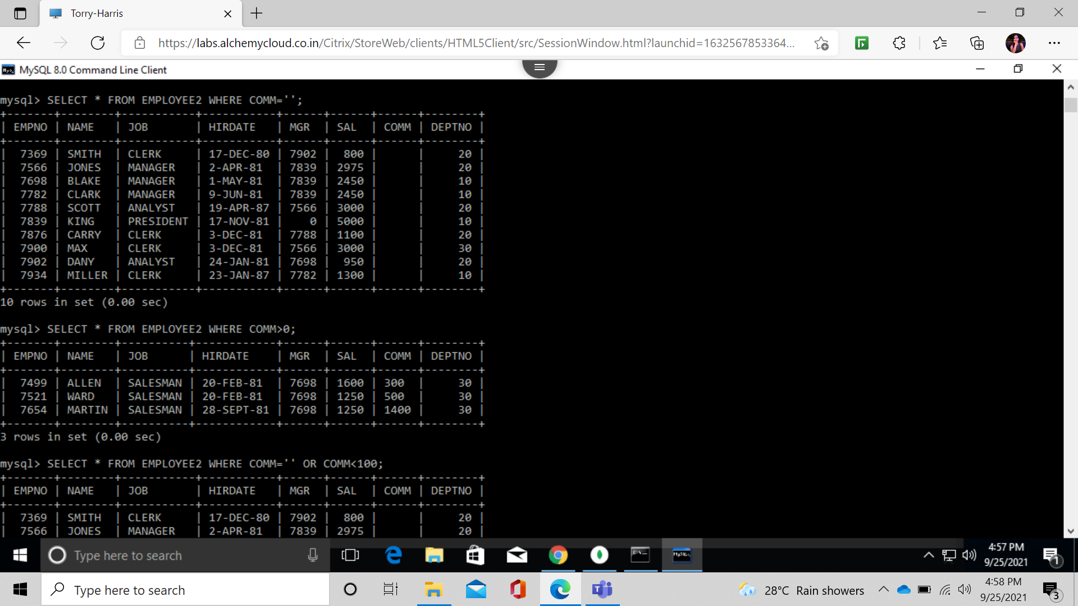

FIND JOBS OF RECIVING COMM



FIND EMP WHO DONT RECIVE COMM OR COMM<100;

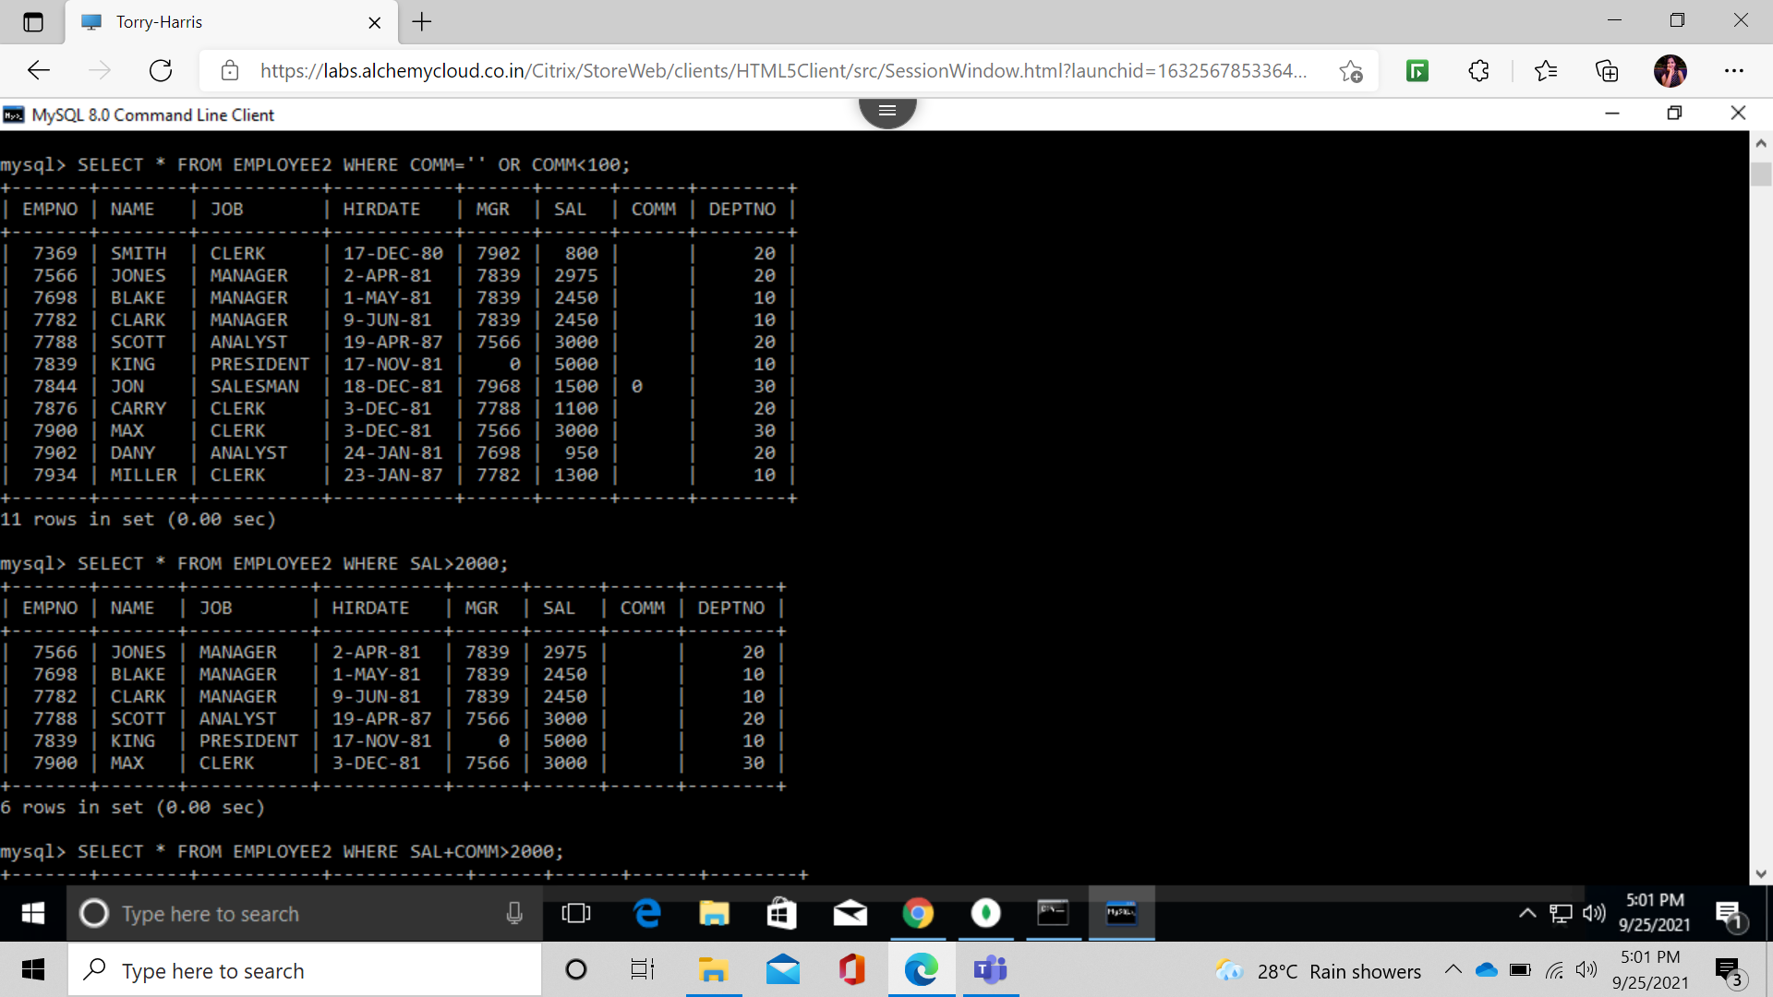

FIND ALL EMPLOYEES WHOSE TOTAL EARNING>2000;

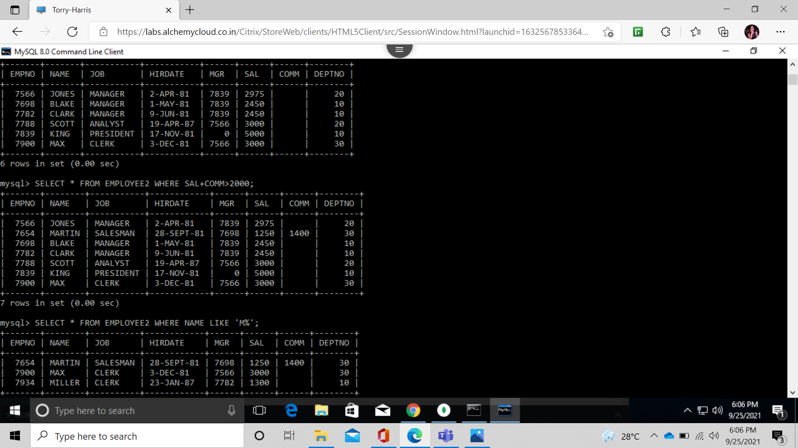

FIND EMPLOYEES WHOSE NAME BEINGS AND ENDS WITH M;



FIND EMP WHO HAVE M IN ANY PLACE;

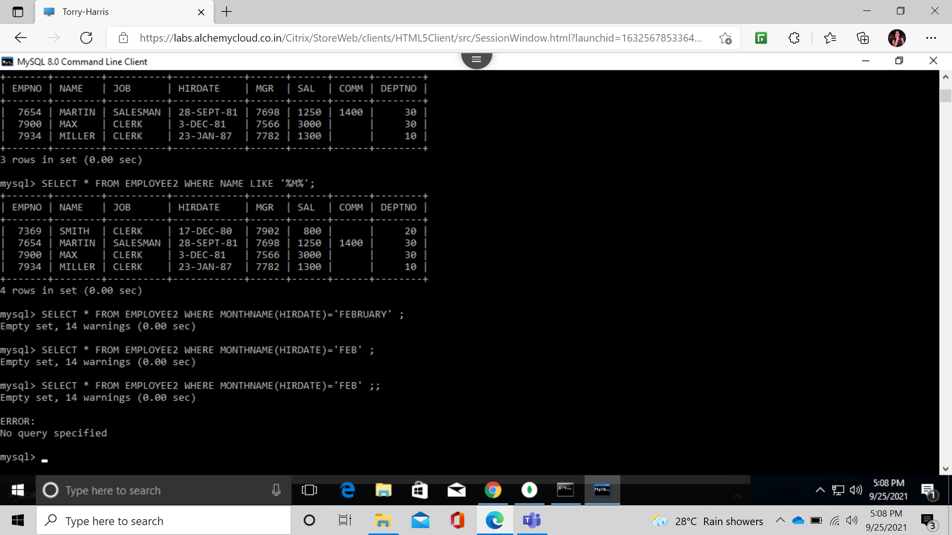

FIND EMPLOYEES WHO ARE HIRED IN FEB;

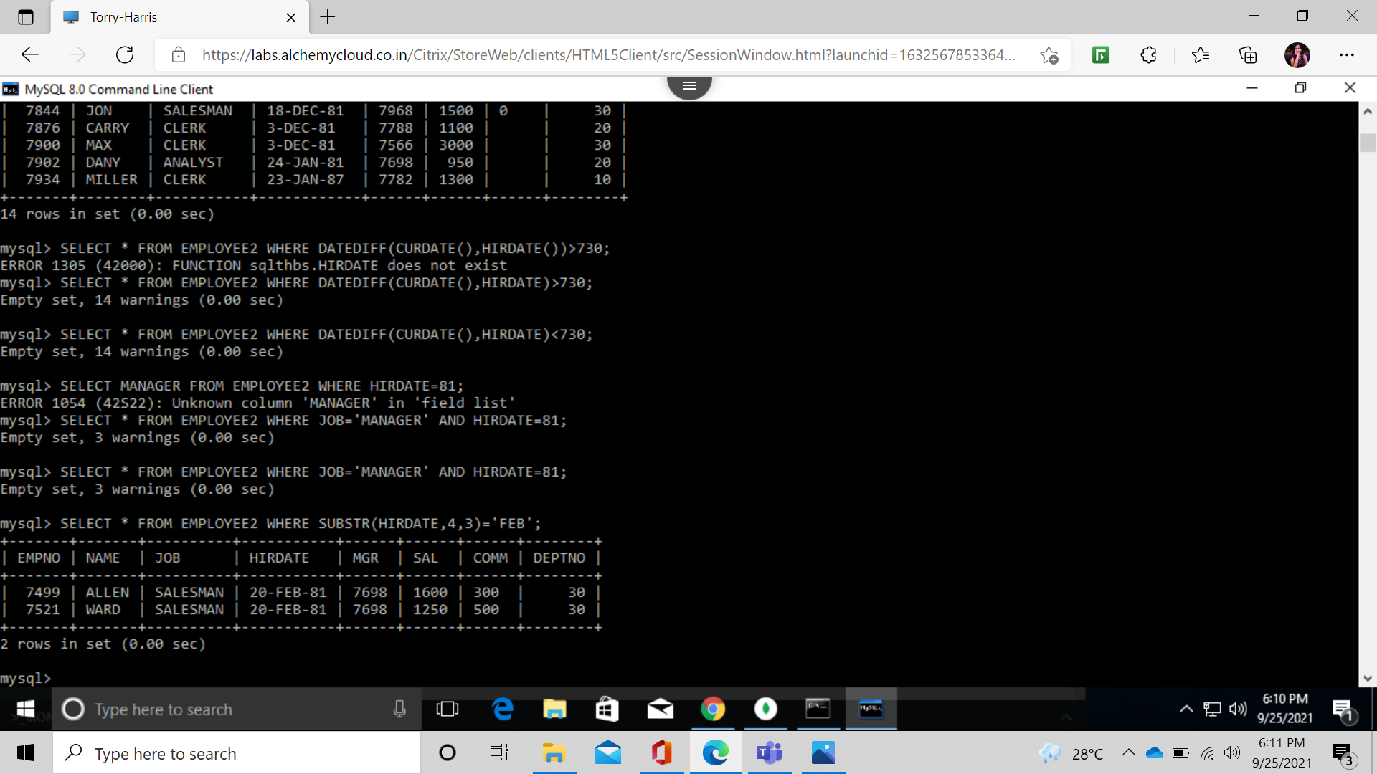

FIND EMPLOYEES WHO HIRED MORE THAN 2 YERRS;

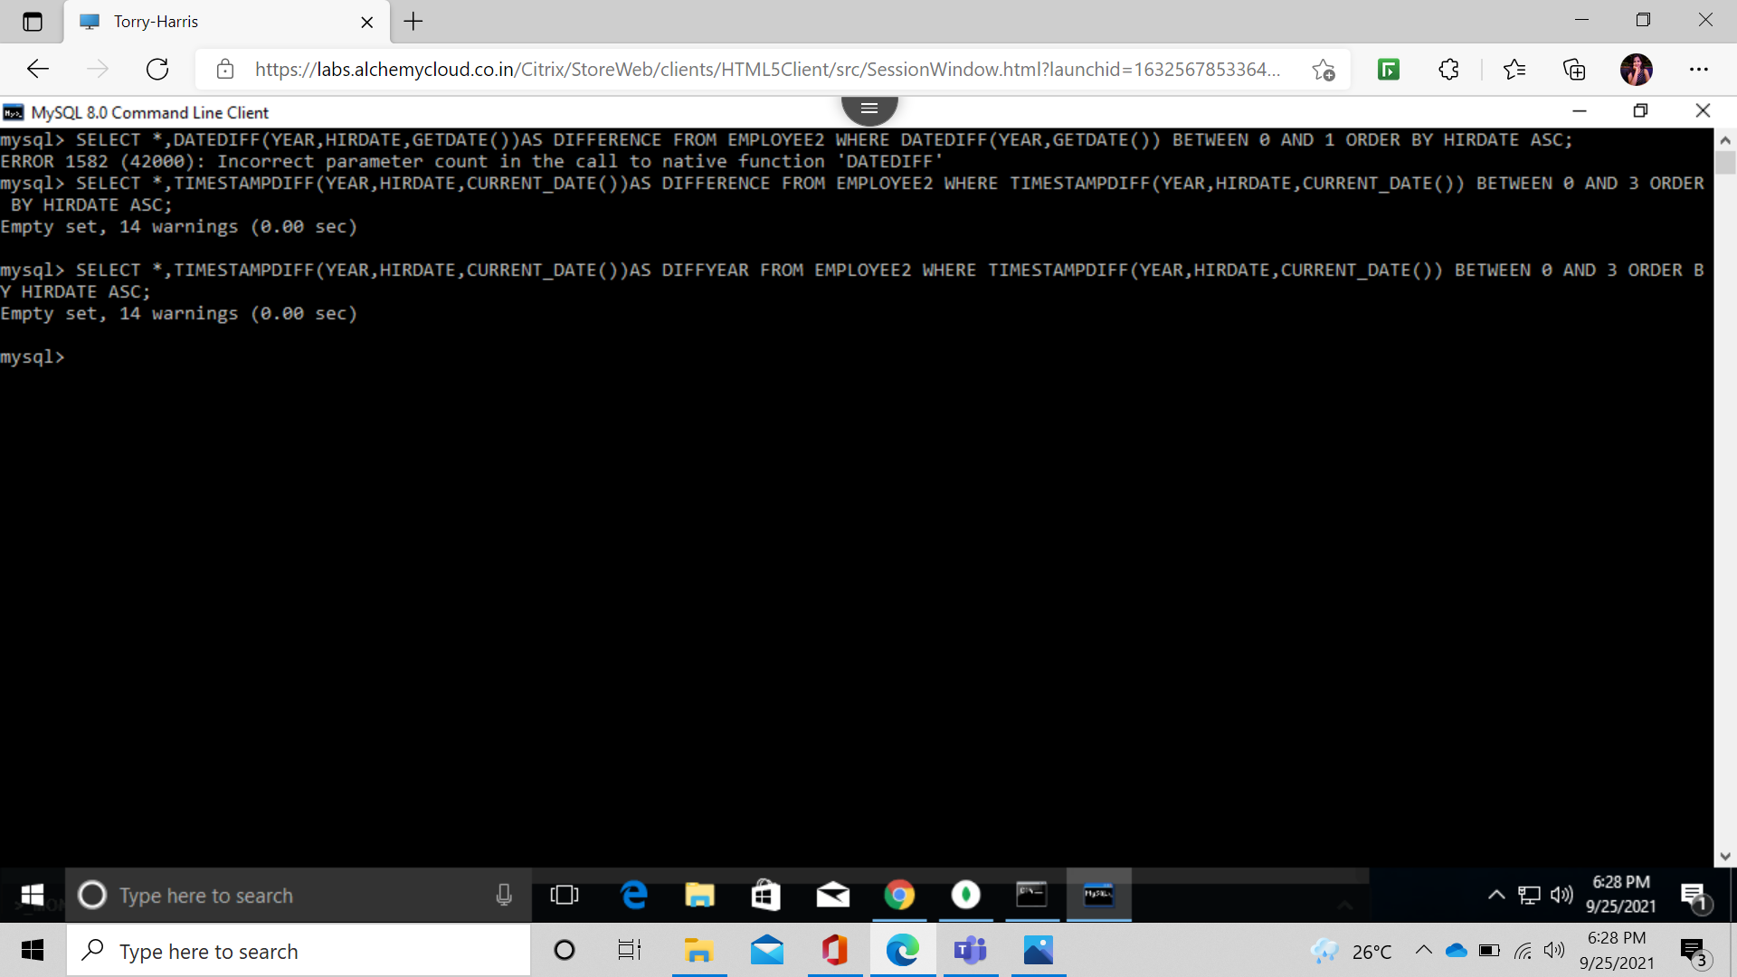

FIND EMP NAMES WITHOUT LEADING A;

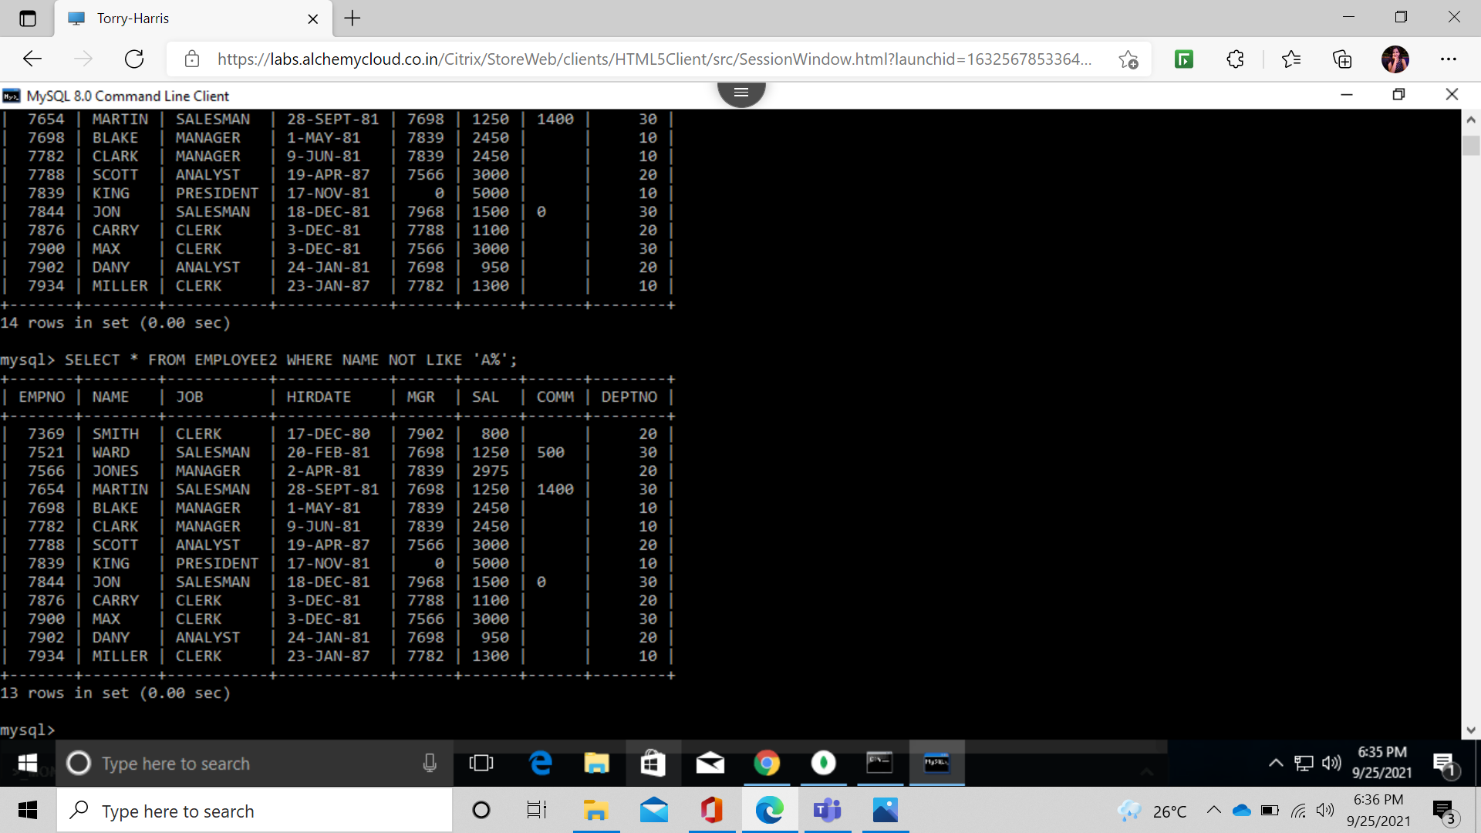

FIND EMP NAMES WITHOUT TRAILING R;

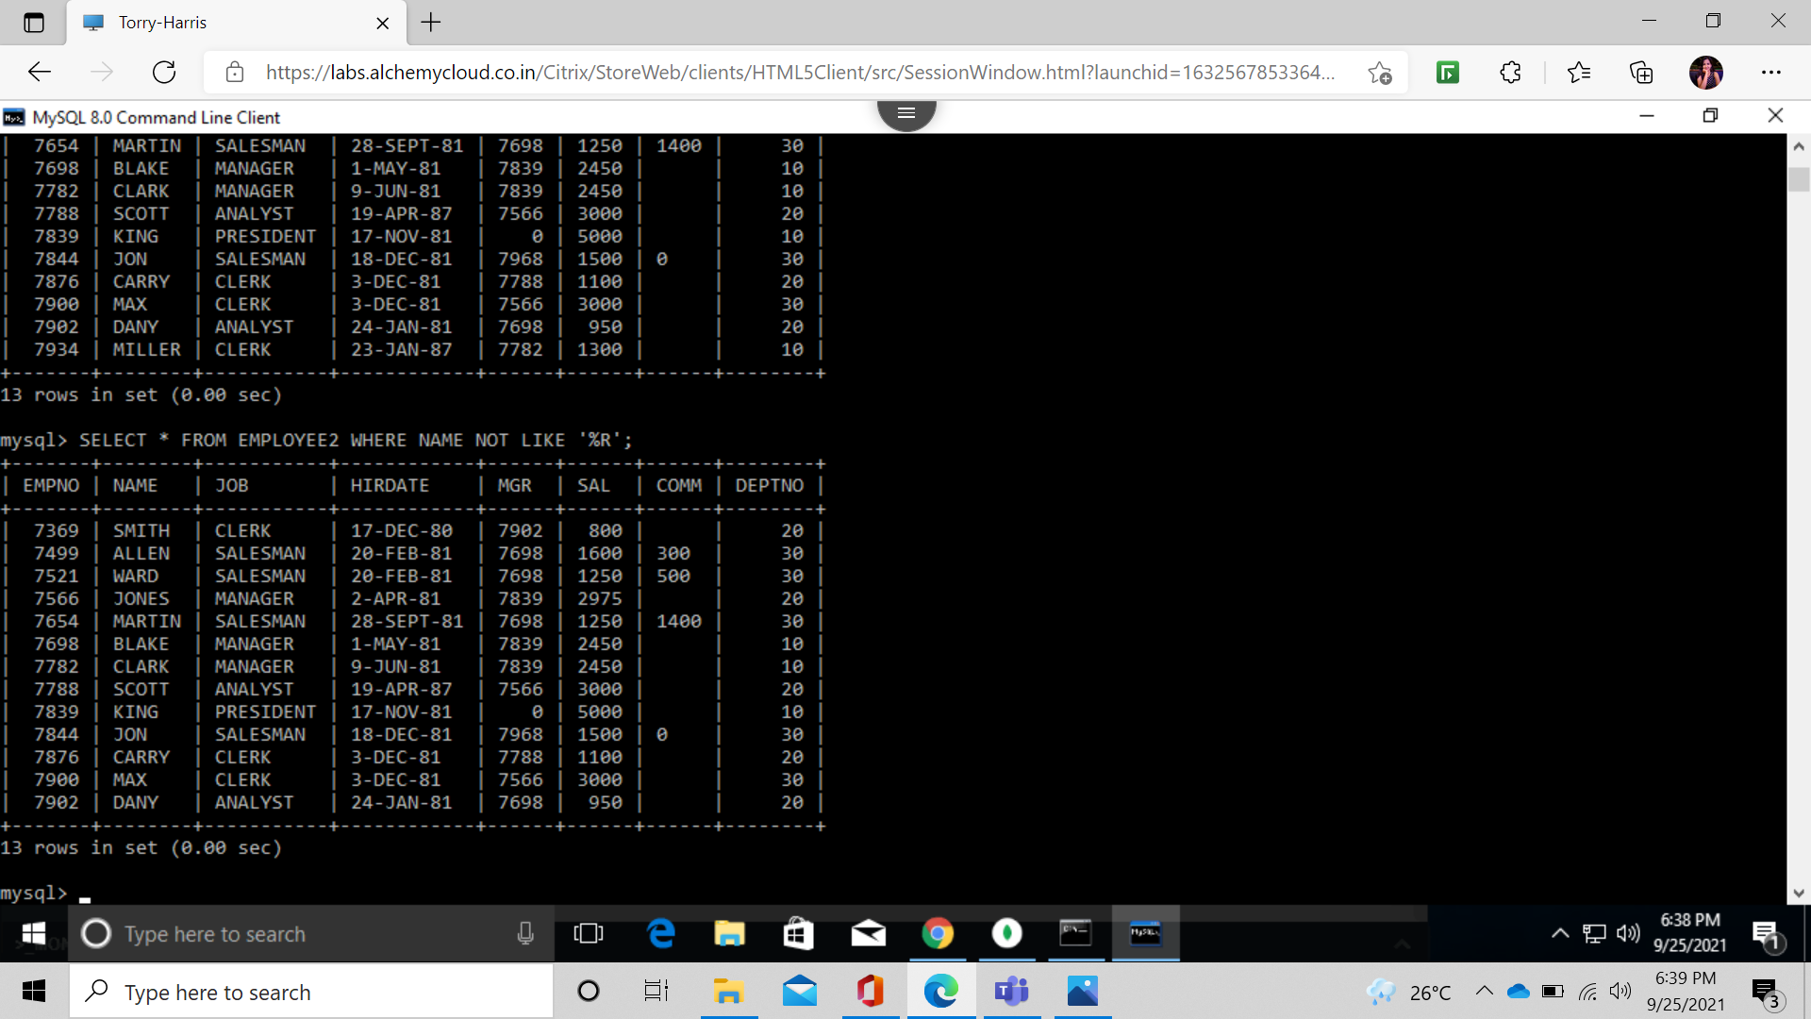

SELECT FIRST 3 CHAR FROM EMP NAME;

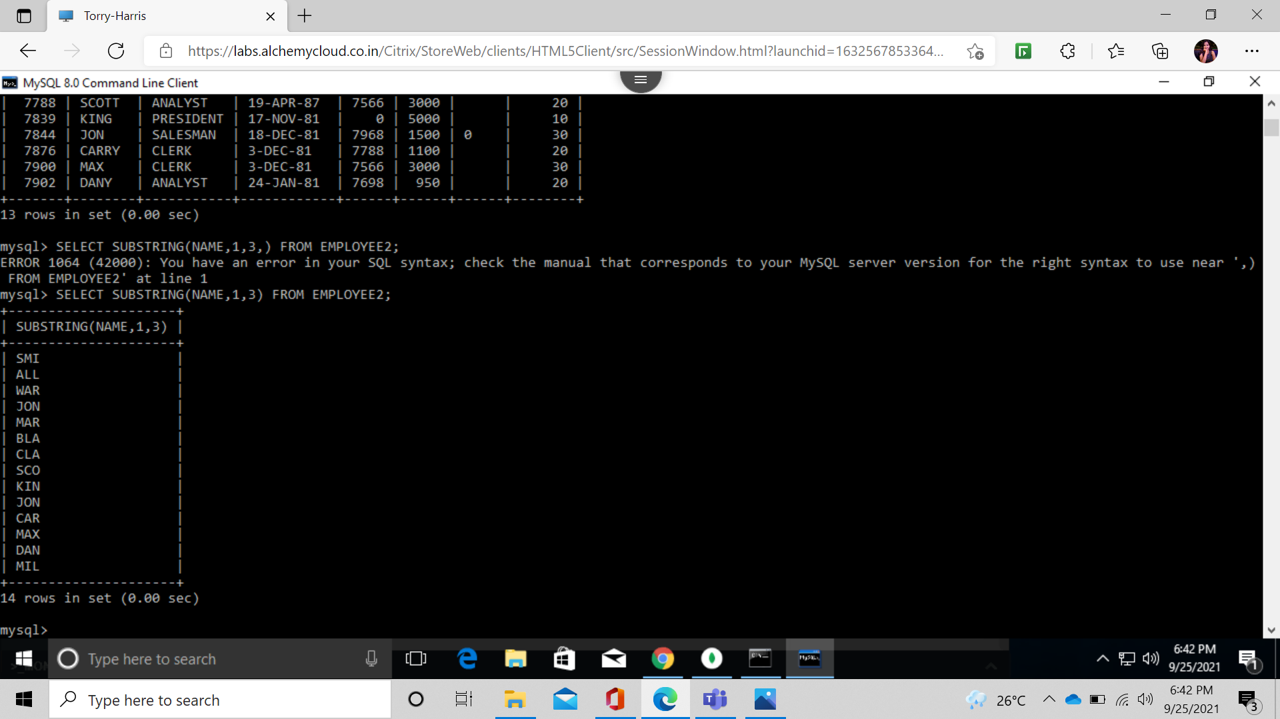

REPLACE A AND PUT a IN NAME OF EMPLOEES;

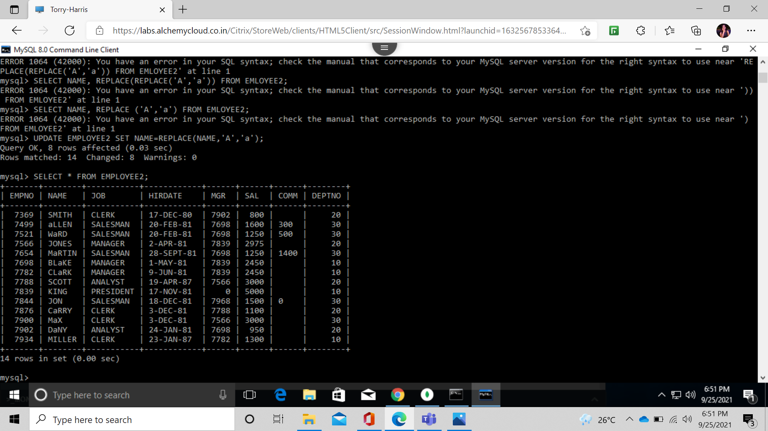

SHOW SAL OF EMP ROUNDING IT TO NEAR RS 1000;

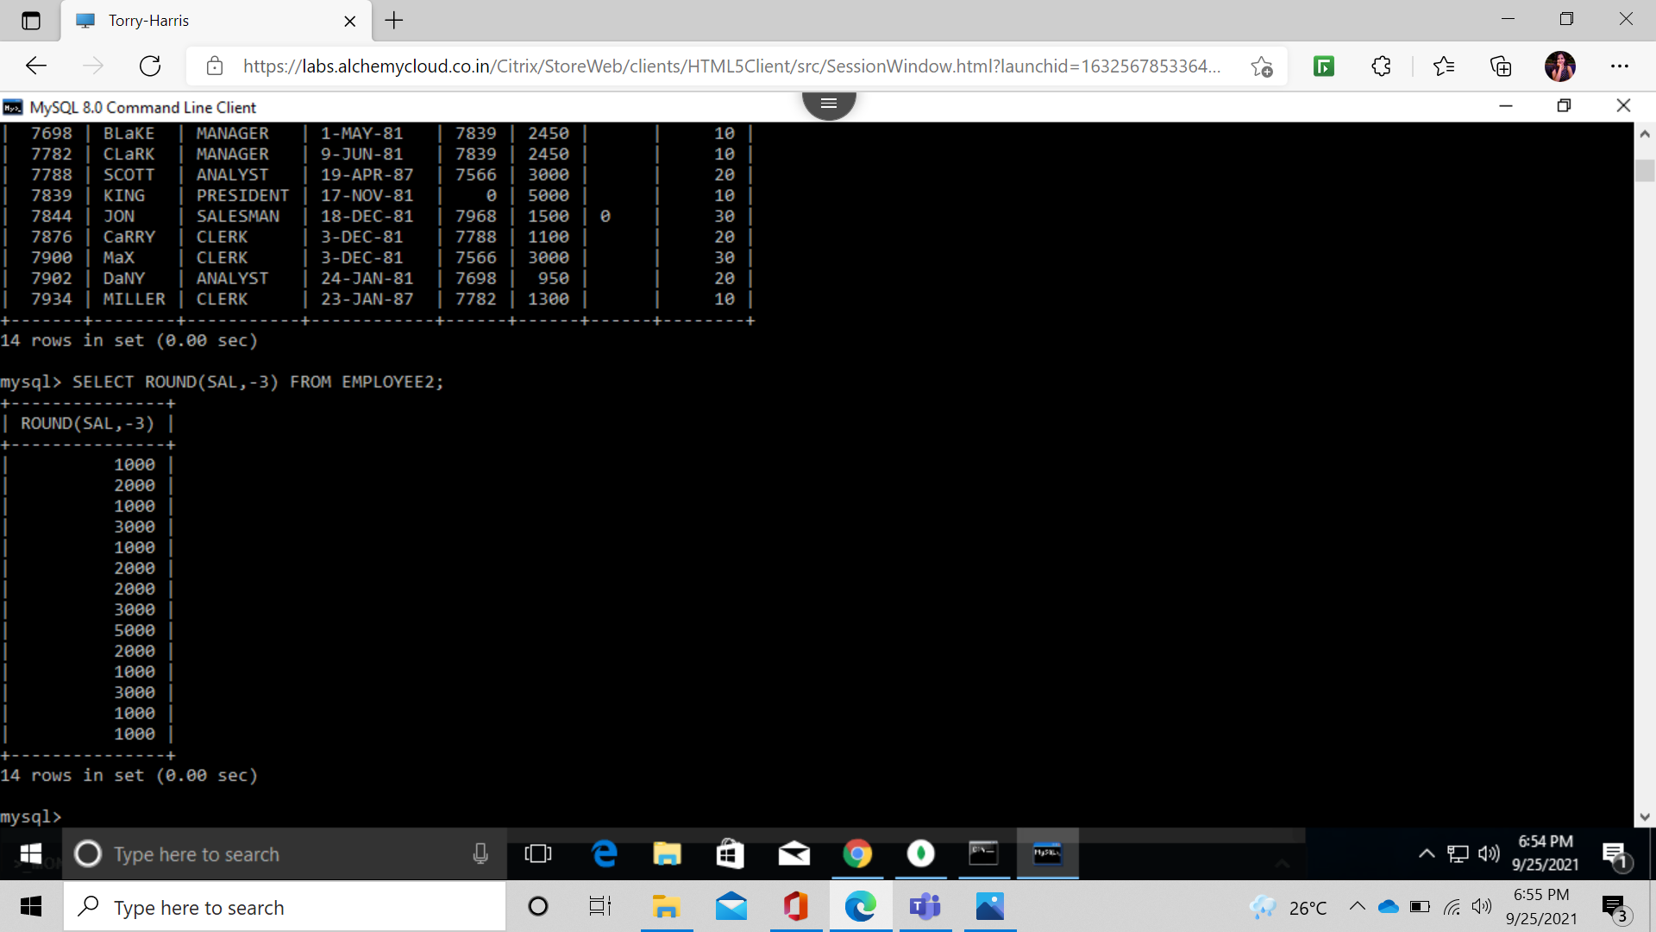

SHOW ALL EMP DETAILS SORTED ON NAMES;

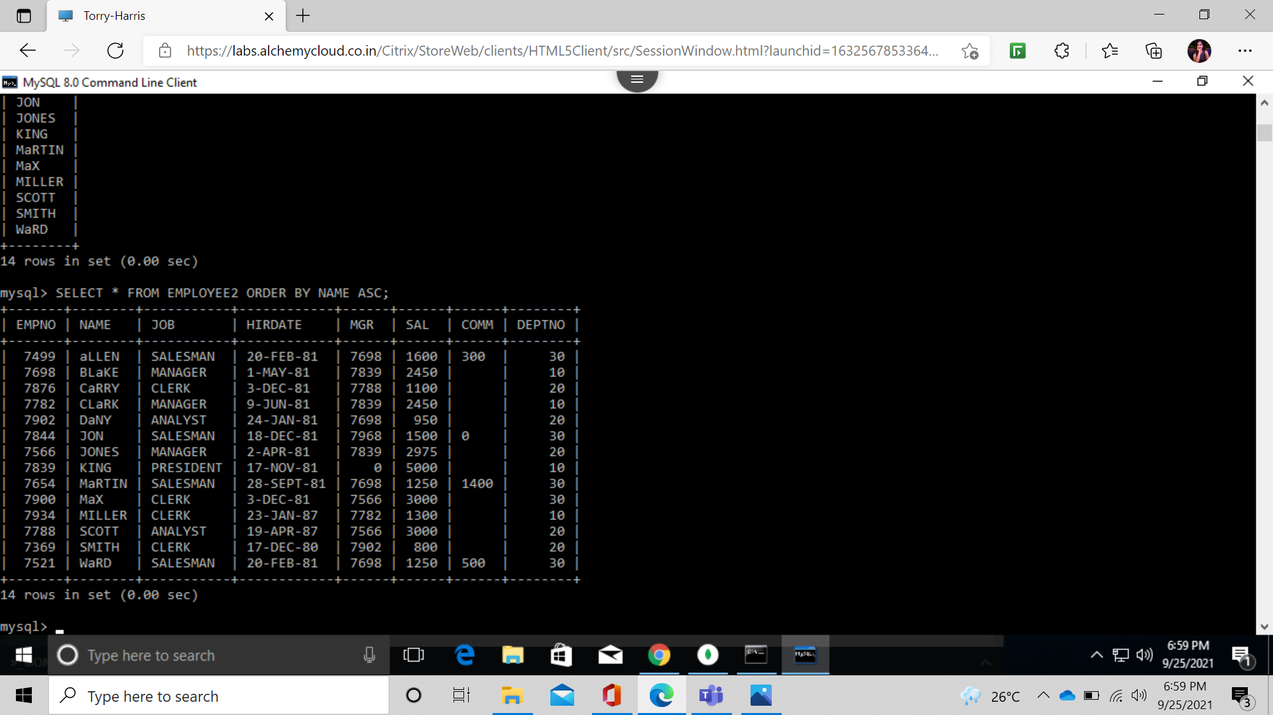

DISPLAY NAME,SAL,JOB OF EMP SORT JOB AND SAL;

